**Azure-functions-automation**

This document details the design and implementation of a serverless automation platform built on **Azure Functions** that enables event-driven processing, API endpoints, and scheduled task execution across multiple business domains. The platform provides a scalable, cost-effective foundation for automating business processes, data processing workflows, and system integrations without managing underlying infrastructure.

The solution replaces traditional scheduled tasks and manual processes with a modern, cloud-native approach that automatically scales based on demand and integrates seamlessly with other Azure services.

**2. Objectives**

The primary objectives of this Azure Functions automation platform are:

* **Event-Driven Automation:** To create responsive, event-driven systems that automatically trigger processing based on various events (storage changes, message arrivals, HTTP requests).
* **Serverless Scalability:** To implement auto-scaling solutions that handle variable workloads efficiently without manual intervention or capacity planning.
* **Cost Optimization:** To reduce infrastructure costs by leveraging consumption-based pricing and minimizing idle resource expenditure.
* **Operational Reliability:** To ensure high availability and built-in fault tolerance through retry policies, circuit breakers, and comprehensive monitoring.
* **Developer Productivity:** To streamline development and deployment through standardized templates, CI/CD pipelines, and local debugging capabilities.

**3. Technology Stack**

| Category | Technology / Service | Justification |
| --- | --- | --- |
| **Compute** | **Azure Functions** | Serverless compute platform for event-driven code execution. |
| **Runtime** | **.NET 6 (Isolated)** | Cross-platform, high-performance runtime for function execution. |
| **Orchestration** | **Durable Functions** | Stateful workflow orchestration for complex business processes. |
| **API Management** | **Azure API Management** | Gateway for HTTP-triggered functions with rate limiting and security. |
| **Monitoring** | **Application Insights** | Comprehensive application performance monitoring and diagnostics. |
| **Security** | **Azure Key Vault** | Centralized secrets management for connection strings and credentials. |
| **Deployment** | **Azure DevOps** | CI/CD pipelines for automated testing and deployment. |
| **Storage** | **Azure Storage** | Blob, Queue, and Table storage for function triggers and data persistence. |

**4. System Architecture & Design**

**4.1. High-Level Architecture**

The automation platform follows a microservices-inspired architecture with independent functions serving specific business capabilities, connected through events and messages.

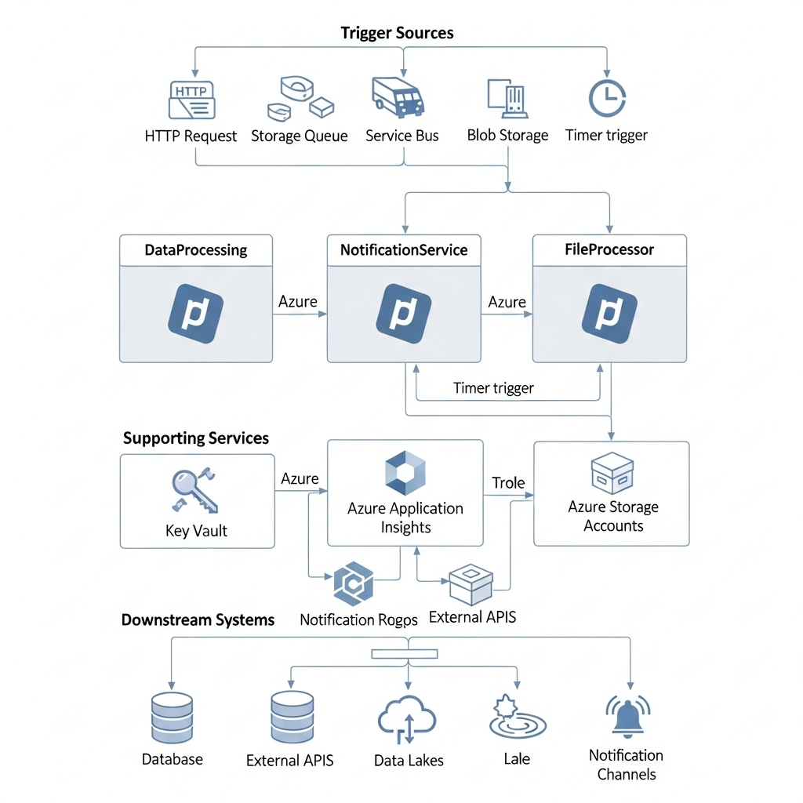

**4.2. Function Patterns Implemented**

**4.2.1. Event Processing Pattern**

* **Blob Trigger:** Automatically processes files uploaded to storage containers
* **Queue Trigger:** Handles messages from Service Bus and Storage Queues
* **Event Grid Trigger:** Responds to system events from various Azure services

**4.2.2. API Pattern**

* **HTTP Trigger:** RESTful endpoints for external integrations
* **Azure API Management:** Unified API gateway with policies and rate limiting

**4.2.3. Orchestration Pattern**

* **Durable Functions:** Complex, stateful workflows with human interaction points
* **Timer Trigger:** Scheduled tasks for batch processing and maintenance

**5. Implementation**

**5.1. Function App Structure**

**5.1.1. Project Organization**

text

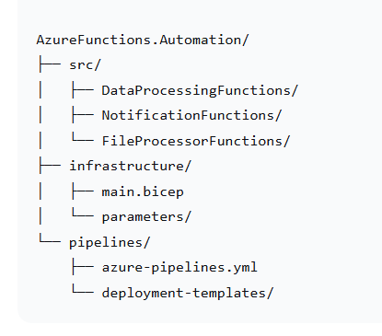

**5.1.2. Configuration Management**

csharp

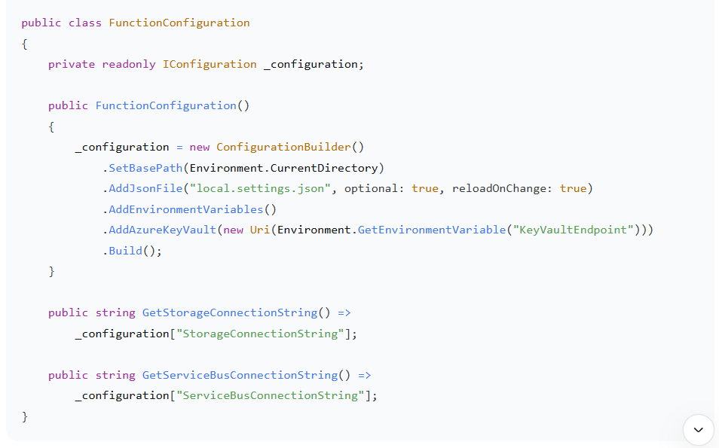**5.2. Key Function Implementations**

**5.2.1. Blob Processing Function**

csharp

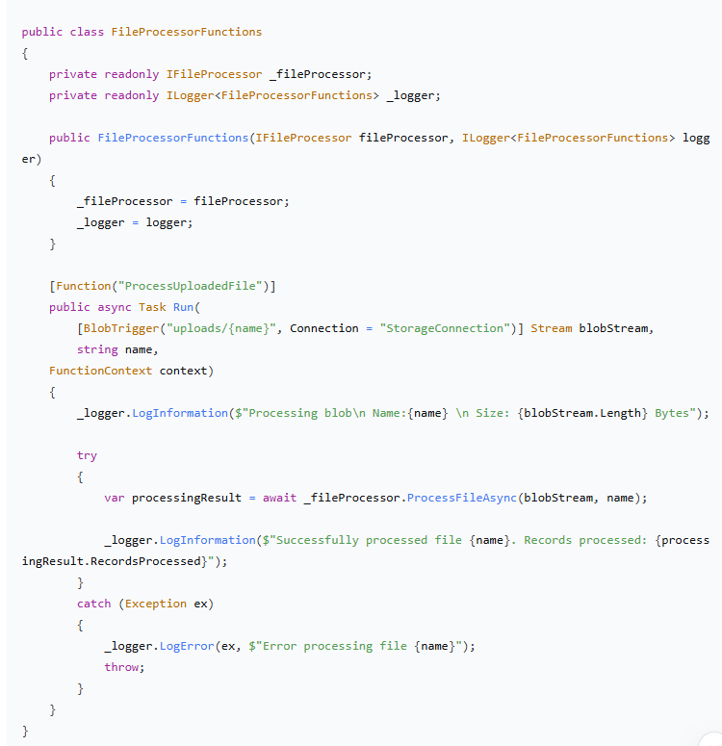**5.2.2. Durable Function Orchestration**

csharp

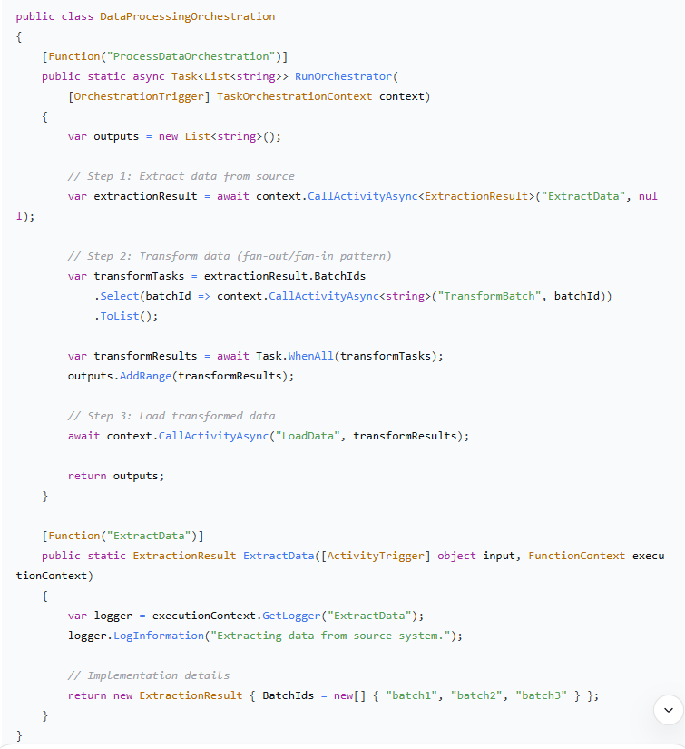

**6. Security & Compliance**

**6.1. Authentication & Authorization**

**6.1.1. Managed Identity Integration**

csharp

*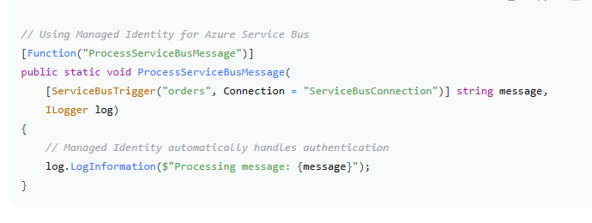***6.1.2. API Security**

* **Azure AD Integration:** JWT token validation for HTTP triggers
* **Function Keys:** Shared secrets for internal service communication
* **Rate Limiting:** Implemented through API Management policies

**6.2. Security Best Practices**

* **No Secrets in Code:** All credentials stored in Key Vault
* **Network Security:** Functions deployed in isolated VNet where required
* **Least Privilege:** Managed identities with minimal required permissions
* **Audit Logging:** Comprehensive logging of all function executions

**7. Monitoring & Diagnostics**

**7.1. Application Insights Integration**

**7.1.1. Custom Telemetry**

csharp

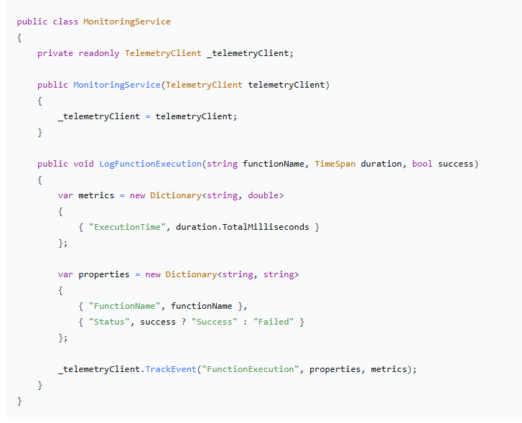**7.1.2. Performance Metrics Tracked**

* **Execution Duration:** Function execution time percentiles
* **Success Rate:** Percentage of successful executions
* **Throughput:** Requests per second per function
* **Resource Utilization:** Memory usage and CPU time

**8. Testing & Validation**

**8.1. Testing Strategy**

**8.1.1. Unit Testing**

csharp

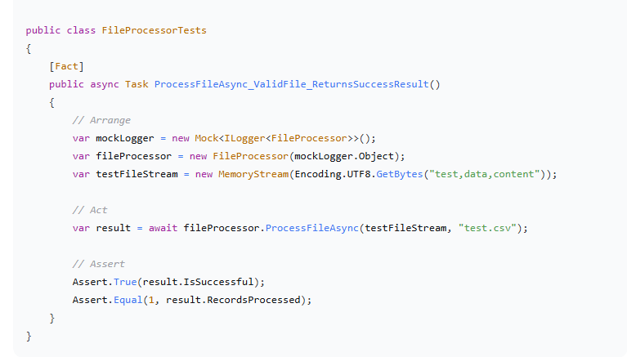**8.1.2. Integration Testing**

* **Live Azure Testing:** Validation of function triggers and bindings
* **End-to-End Testing:** Complete workflow validation with test data
* **Load Testing:** Performance testing with simulated production loads